RFID

Reader

Application System.

Graphical user interface

(GUI)

Database

**Figure 1 (RFID ATTENDANCE SYSTEM)**

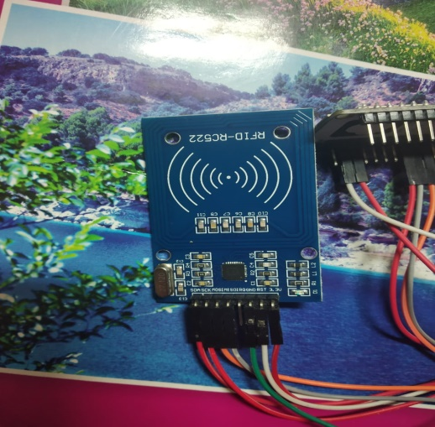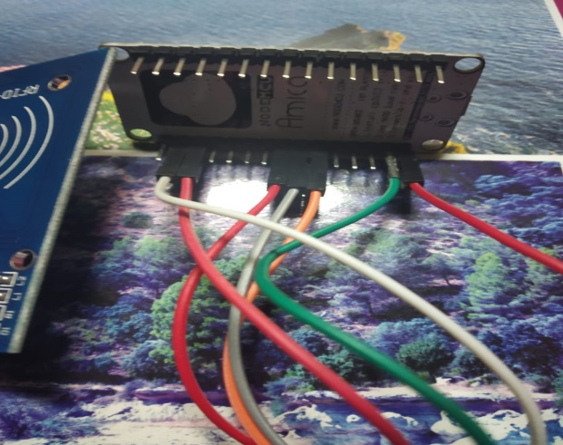

**Figure 2 (Arduino)**  **Figure 3 (RFID Reader)**

# SYSTEM ARCHITECTURE

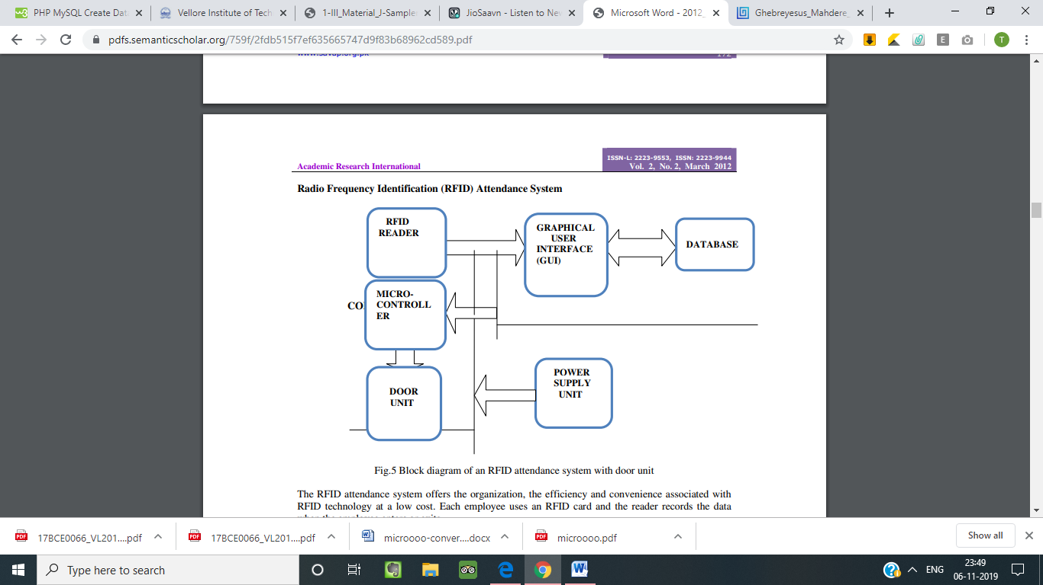

**Figure 4 System Architecture**

The RFID attendance system provides low-cost management, reliability and comfort related to RFID technology. That employee uses an RFID card, and when the employee enters or leaves, the reader records the information.

# EXTERNAL ARCHITECTURE:

RFID

Reader

Computer

Graphical user interface

(GUI)

Database



**Figure 6 (Internal Architecture)**